**Exercise 2 – Recruiting a Wide Player**

**Addison Wood** | Nashville SC | Data Analyst - Application Project

**Shortlist**

1.     ***Hassani Dotson****(USA) – 24 y.o. – Minnesota United - $81,375 – (2021)*

·      Minnesota United typically plays Dotson as a center mid, although he’s seen significant time (2,320 minutes) on the flanks, particularly at right back.

·      He is significantly above average in 1v1 dribble success %, cross completion %, pressures per 90, fitness, and versatility.

·      The only area he is below average in is 1v1 tackle success %, where he is in the 40th percentile of outside players in the last few years.

·      As a former SuperDraft player currently making the minimum senior salary, Dotson looks not only to be a plus on the field, but in the club’s roster construction

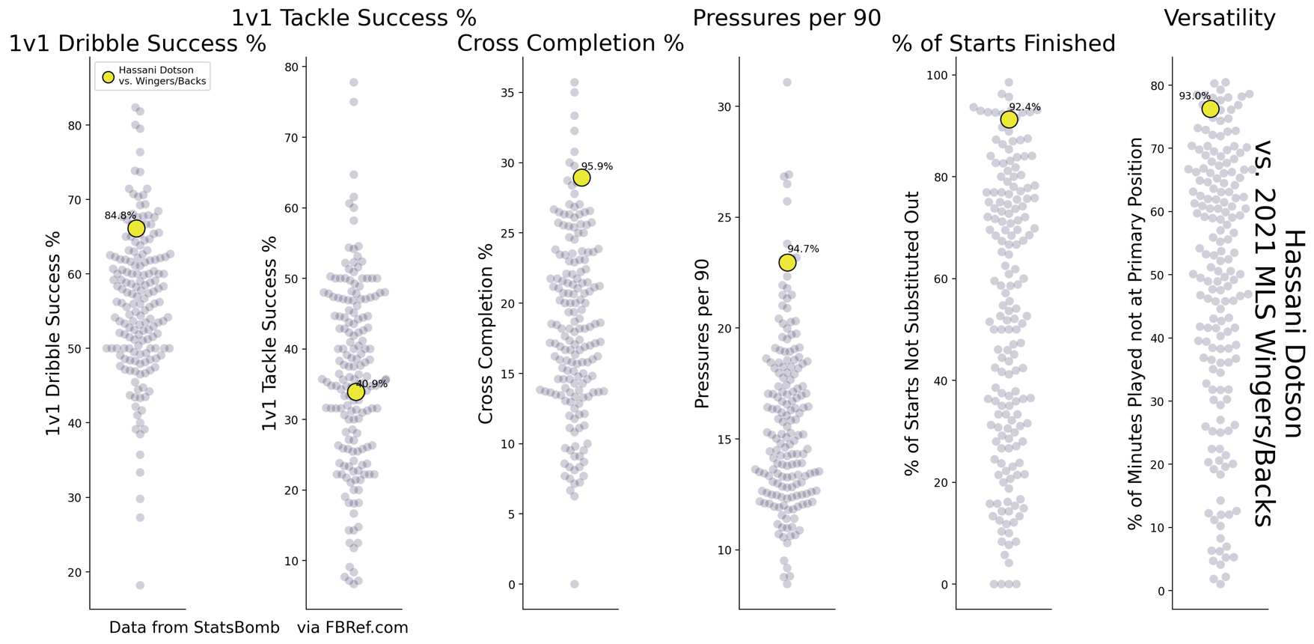

2.     ***Russell Teibert****(CAN) – 29 y.o. – Vancouver Whitecaps - $387,000 (2021)*

·      Although listed as a forward on the league website and a center mid on FBRef, Teibert has played just over 1,000 minutes on the flanks, the bulk coming from left mid.

·      When in those positions he has performed well, particularly in his crossing, in which he is the best crosser on the flanks, with at least 0.5 crosses per 90

·      Better than average 1v1 defending as well.

·      His 1v1 dribbling, match fitness, and versatility are all hovering around average-but not poor.

·      Teibert’s value lies in his exceptional crossing ability and his extensive MLS experience

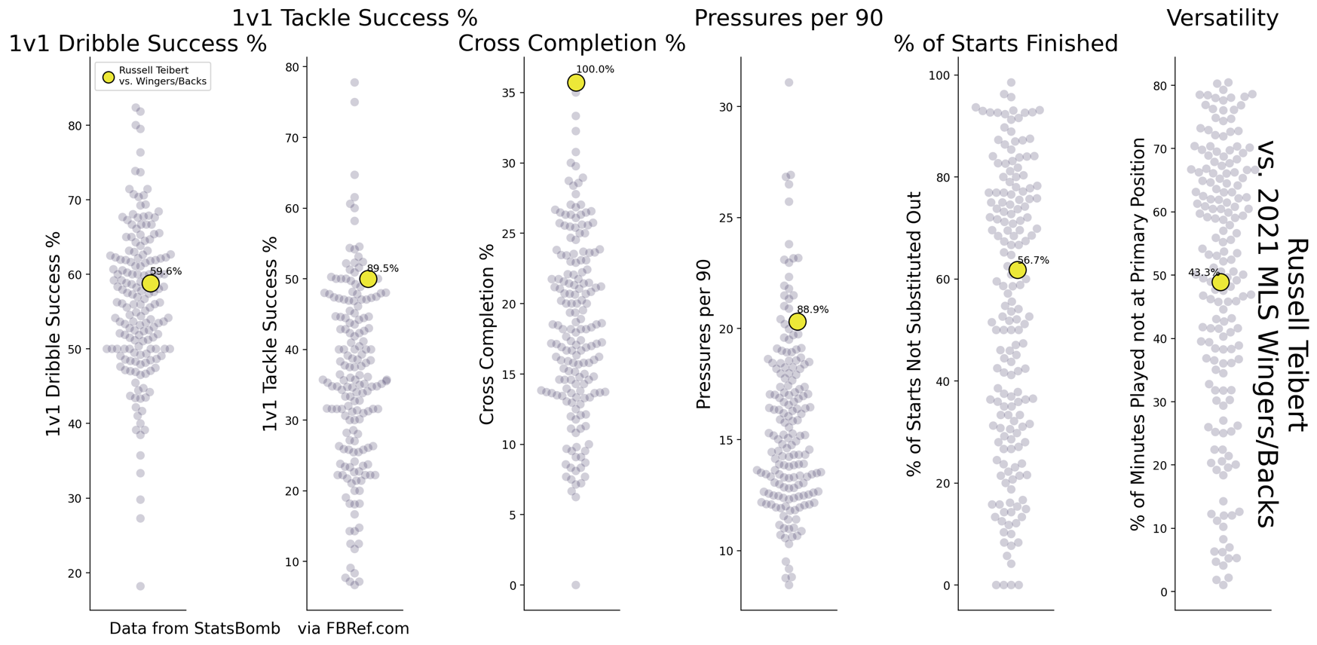

3.     ***Kyle Smith****(USA) – 29 y.o. – Orlando City - $118,660 (2021)*

·      Above average in all of the selected statistics relating to 1v1’s, crossing, fitness, and versatility, Smith is a well-rounded outside back

·      Almost equal experience on the right and left side (1,334 and 1,278 minutes, respectively – since 2019).

·      Although not particularly outstanding in any metric, he is above average in them all.

·      As an American, Kyle Smith is a roster-friendly choice as well.

·      At 29 years old, however, he is likely at or just past his peak.

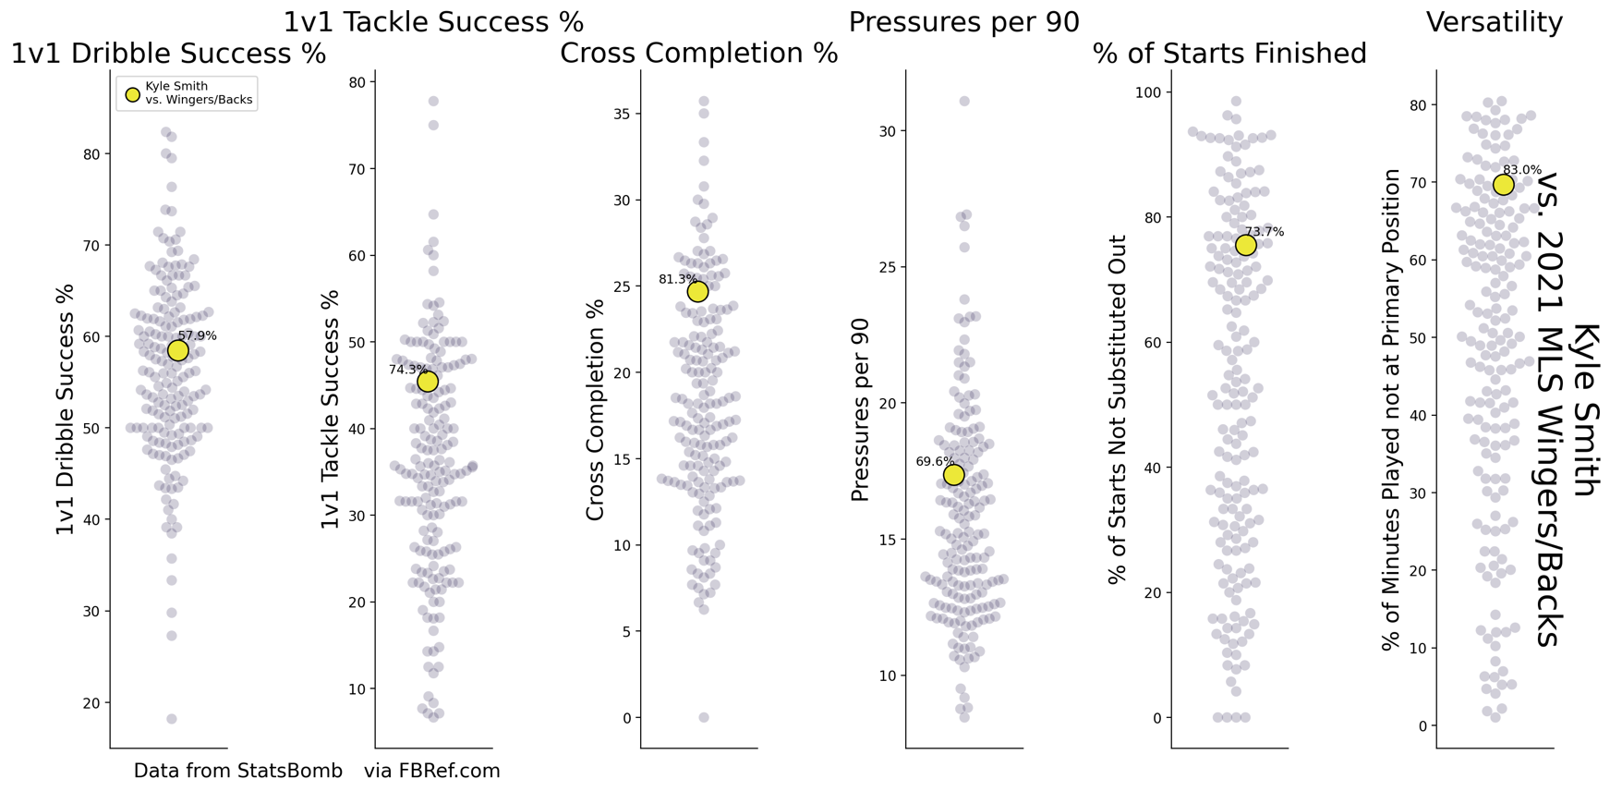

4.     ***Brooks Lennon****(USA) – 24 y.o. – Atlanta United – ($375,000)*

·      Lennon has a more attacking mindset than the others on his list, with exceptional 1v1 dribbling and crossing metrics (both % success and volume).

·      However, he has just below average defending metrics.

·      As a fast and dangerous player, Lennon would provide value from the flanks as an attack-minded winger with reduced defensive responsibility, or a wing-back with significant center back coverage.

·      Atlanta United exercised their club option on 11/30/21, so they may not be looking to part with him easily

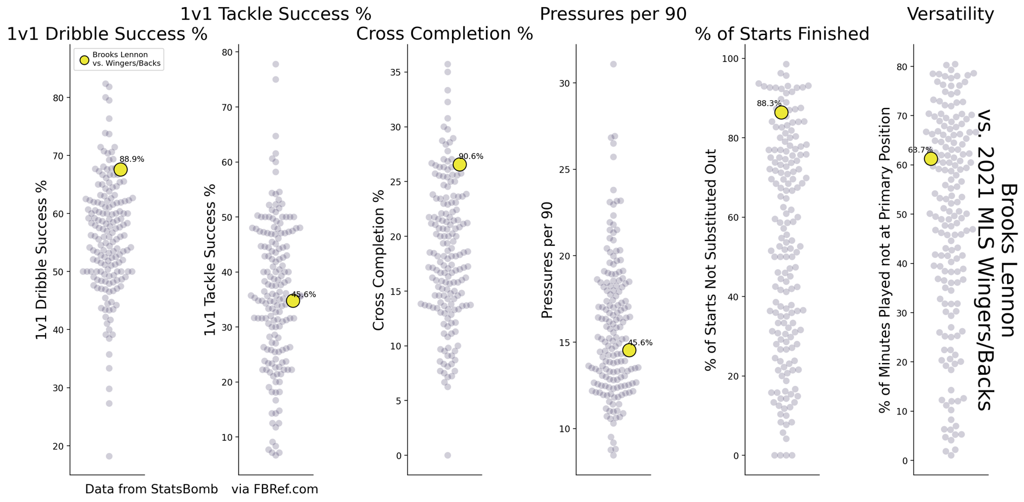

5.     ***Javain Brown****(JAM) – 22 – Vancouver Whitecaps - $63,547 (2021)*

·      New to MLS in 2021, Brown was a solid outside back for the Whitecaps in 2021.

·      At 22 years old, he is already a dangerous 1v1 attacking, successfully dribbling opponents more often than 98.2% of his peers on the flanks.

·      On the defensive side of 1v1s, Brown is already solid as well, as he is in the 77th percentile for 1v1 tackle success.

·      His cross completion is entirely average (in the 59th percentile), but not poor.

·      Brown’s work rate is not a problem, being in the 75th percentile for pressures

·      However he has been substituted out ~50% of his starts.

o   As a young player new to MLS, this may be due to inexperience more than poor match fitness.

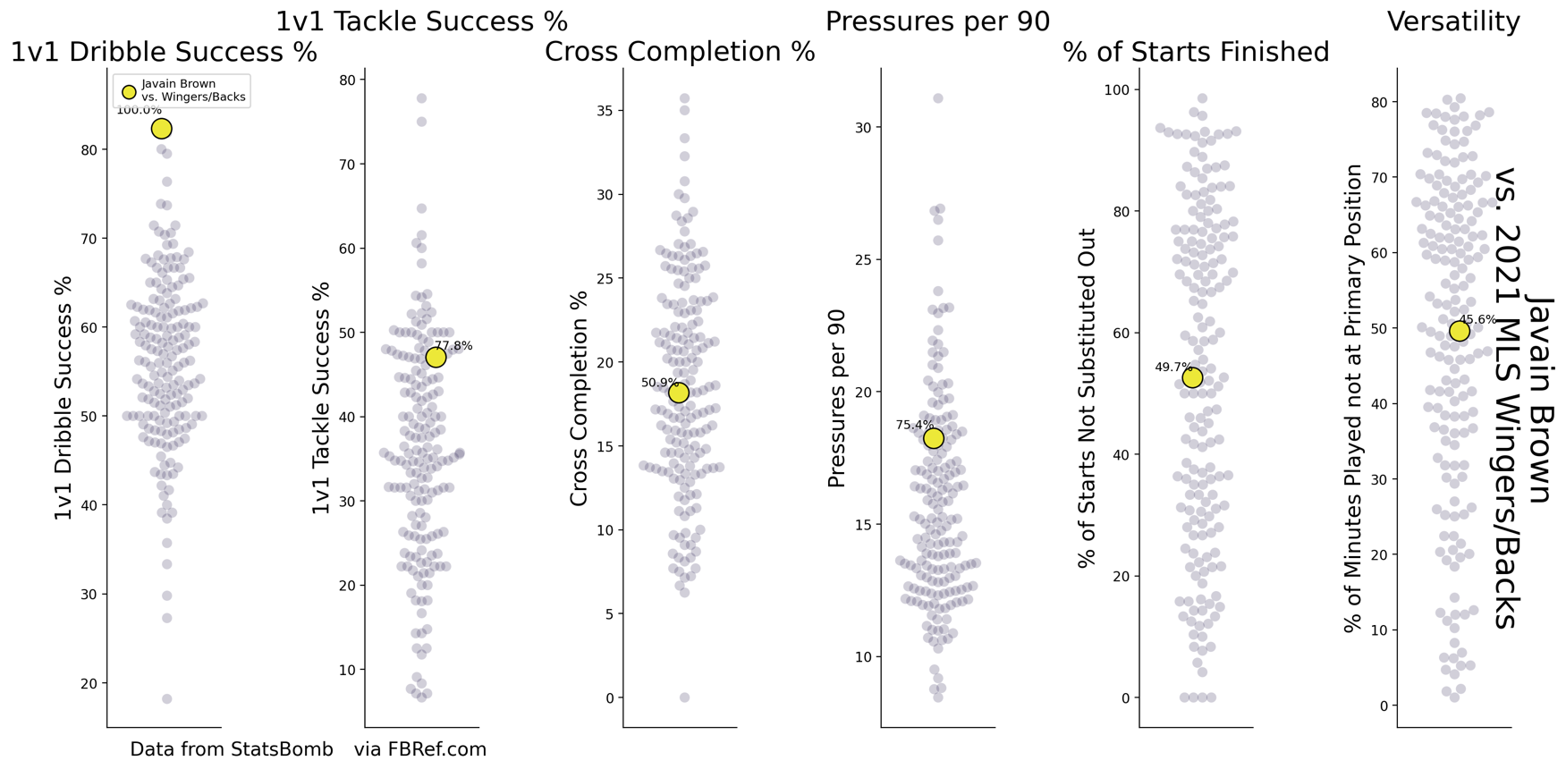

o   **Notable Exclusions:**

o   ***Christian Roldan****(USA) – 26 – Seattle Sounders - $881,542 (2021)*

§  Roldan would otherwise be in the shortlist with exceptional versatility, fitness, and 1v1 dribbling compared to his peers, but his salary is already at Designated Player level, and it would likely take a significant raise for him to move to another team within MLS.

o   ***Boris Sekulic****(SVK) – 30 – Chicago Fire - $643,900 (2021)*

§  At 30 years old, Sekulic was a year too old for consideration. He is likely just around his peak as an outside back/wing back, and paying DP-threshold wages for a player likely to decline in productivity would likely not be as smart of a roster decision as a younger player of slightly less current ability would be.

o   ***John Tolkin****(USA) – 19 – New York Red Bulls - $90,444 (2021)*

§  Tolkin has generally above-average metrics in the target areas (especially crossing – in the 88th percentile), but as a promising young player fresh out of the Red Bull’s academy, he is unlikely to move to another MLS team any time soon. If he were to move soon, it would likely be overseas.

o   ***Justin Che****(USA) – 18 – FC Dallas - $89,209 (2021)*

§  His crossing and 1v1 defending metrics are great (90th and 89th percentiles, respectively.

§  His versatility on the flanks so far has been poor, he has only been a right back when playing out wide.

§  His demonstrated ability to play at the wide right CB role as well would be a perfect replacement for Alistair Johnston (although not a plus when recruiting for a wide player).

§  Che is in the same situation as Tolkin, as a fresh graduate of the FC Dallas academy and USL standout. He is significantly more likely to join Bayern Münich’s reserves than to join another team in MLS

**Search/Exclusion Methods**

o   All game stats for this exercise were pulled from [FBRef](http://fbref.com/), past injuries and transfers were pulled from [Transfermarkt](https://www.transfermarkt.us/), and recent transfers and 2021 salaries were pulled from [Spotrac](https://www.spotrac.com/mls/transactions/).

o   The first step for this exercise was to isolate FBRef MLS data from 2019-2021 for all players with at least 720 minutes listed at a wide position

o   In addition, I excluded players that were 30 or older in the 2021 season.

o   Playing on the flanks is physically demanding, and players tend to peak early and decline quickly (or get moved centrally)

o   From there, I excluded all players that did not meet the requirement in 2021.

o   (ex: Jorge Moreira would be been on this list based on 2020 data, but he returned to Argentina after that season)

o   The first step for this exercise was to identify metrics at my disposal that could successfully profile the required abilities

o   1v1 Attacking – Dribble Success % (min. 0.5 dribble attempts per 90 – otherwise excluded from search)

§  This could be made more robust with event data x,y coordinates to isolate dribble success% on the outside thirds of the pitch

§  I parsed data to only include games in which the player is listed at a wide position, in order to somewhat my lack of location data.

o   1v1 Defending – Tackle Success % vs. Dribbles (min. 0.5 tackles vs. dribble attempts per 90 – otherwise excluded from search)

§  Again, could be made robust in the same way with event location data.

o   Crossing – Cross Completion % (min. 0.5 crosses per 90 – otherwise excluded from search

§  FBRef does not have a cross % metric on its site, but it does have a crosses attempted metric, as well as a crosses completed in the penalty area metric.

§  I made the assumption that the vast majority of crosses are targeted at the opposing penalty area (as the cross metric is distinct from a switch pass), rendering the created cross completion % metric theoretically valid.

o   Fitness – (1) Pressures/90, and (2) % of Starts Finished

§  With tracking data, distance travelled per 90 would be a more reliable fitness metric than pressures

·      Pressures are significantly affected by team playing style, and while they can be an indicator for fitness, they are not reliable as a single metric for fitness.

·      A way to improve it with event data would be to track the change in pressures (against team pressures) across the course of a game

§  My second metric to fill some of the cracks left by pressure volume is % of starts finished.

·      Basically, this is just the percent of games started by a players where they finish the full 90 and are not subbed out

·      As with pressures, this could be affected by managerial decisions, as a tactical sub would be interpreted as a fitness sub

§  In all, a fitness metric utilizing tracking data (or even event data) would be significantly more trustworthy than the count data available for free online.

o   Versatility - % of Minutes Played not at Primary Position

§  Tracking data could make this data more robust, as FBRef only lists positions played in a match, not average position or minutes in individual games at different positions

·      Theoretically this is possible with WhoScored (which makes itself virtually unscrapeable), but assumptions about the color/value mapping in the heat maps would have to be made.

o   Each of these metrics were normalized to a scale of 0-1, to make a weighted average easier.

o   For this shortlist, I created a weighted average of these 6 metrics encompassing 5 traits.

o   The traits were weighted as such:

§  1 – Attacking 1v1s

§  1 – Defending 1v1s

§  1 – Crossing

§  0.5 – Fitness

§  0.5 – Versatility

o   Fitness and versatility were reduced due to the uncertainty of their selected metrics

o   I then reduced the player list to just the top 20 by this weighted average

o   Using Transfermarkt and Spotrac, I made sure that they had not recently moved (ex: Jaylin Lindsey) or hadn’t been plagued by injury in the last couple years (ex: Paxton Pomykal)

o   From there, I selected the best 5 by that weighted average, excluding signings that were not realistic or poor roster decisions (noted in the *Notable Exceptions*section above)